The Sales Submarine
Imagine the sales process as a submarine with different departments. Much like you would do in a submarine that was filling with water, with the Sales Submarine you go from one step to the next, “closing off the compartment doors of the Submarine behind you as you move forward.” You take the prospect from one sales step to the next and completely close off the step behind it.
Important: You will only ever revert back to Pain step and do so any time that you need to.
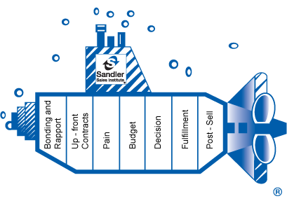

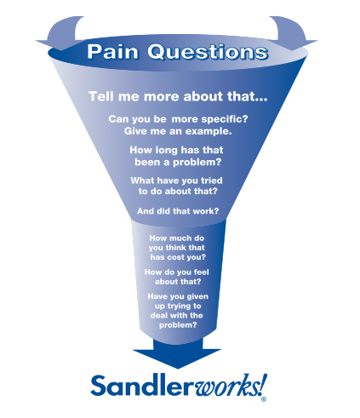

1) Bonding and Rapport (2-3 min.) → Make the prospect comfortable.
- Make small talk about anything that you can relate with them on.
- "Match" your prospect's volume, rate of speech, tone, accent, favorite phrases, etc.
2) Up-Front Contracts (5-6 min.) → Gather their needs and set the agenda.
- Ask quick questions to understand their business, establish their Goals and begin collecting Pain. This step also helps you to identify which Product/Service is ideal.
a. “What type of investing do you do? How many deals are you currently doing? What type of money do you want to make?” [Get niche focus and establish their Goals]
b. Do you currently have a website? If so, how much traffic do you get daily? How many leads do you get for the traffic? [Web 2.0 Product Setup]
c. “How many business coaches do you currently have? If not, do you feel having a coach could help you grow your business?” [Coaching/Mentoring Setup]
- Establish what they would like to include in the meeting agenda:
a. "George, what would you like to have accomplished at the end of our meeting?"
- Always agree to discuss their proposed agenda items then add your own agenda:
a. “Great. I would also like to spend a little time on the biggest barriers you are having in your business (their ‘Pain’) as well as decide whether or not you are a good candidate for (product/service). We will talk more about (product/service later, but it seems like it could be an ideal fit.” [Set up sale such Web 2.0 and/or Coaching based on answers]
3) Pain (7-8 min.) → Expanding upon their needs and problems.
- Dig deeper to find additional Pain items to add to your list.
a. “We have a few items here that need attention, but what would you concider to be the biggest barriers in your business that are stopping you from (your Goal)?”
- Expand on the Pain items you collect from all previous steps by asking questions (in other words, take them down the Pain Funnel).
NOTE: You want to make prospect “Critical” without letting them go “Not O.K.”
a. “It says here you have a problem with (pain), how long have you had the problem?"
b. "Have you tried to fix it in the past?" "Did it work?"
c. "How much money could you be making if it was fixed?"
d. Ask for more details. "Can you tell me more?" or "Can you be more specific?"
4) Budget (1-2 min.) → Find out the miminum they are willing to spend.
- Set up the Budget question with a softening statement:
a. "You have shared with me (your Goals) and that in order to reach those goals you must first deal with (list Pain). Now we need to figure out what action you are going to take today to get overcome these barriers and reach your goals.”
- Find out how much money they have to spend to reach their Goals and end their Pain.
a. “Do you have a budget set aside to invest in your real estate investing business?"
i. If yes… "Would you mind sharing it with me in round numbers?"
ii. If no… “You do recognize that in order to succeed in any business you will
you will need to invest in yourself and your business, correct? Would you rather
wait around and maybe never take steps to reach your goals or take a small step
immediately toward reaching your goals today?
5) Decision (1-2 min.) → Confirm that they have the authority to buy.
- Set up your Decision question with a softening statement:
a. “Thanks for helping me to understand your financial ability to invest into your business, we can work to see if we can help you get past (your Pain) with that budget.”
- Find out if they are able to make a buying decision:
a. “I was wondering about the decision-making process you go through when making a business move like this. Besides yourself, who else is involved in the decision making?"
- Confirm that they are telling you the truth:
a. (Gently) "You mean you don't get any help a spouse or a business partner?"
6) Fulfillment (CLOSE) (5-6 min.) → Relieve their Pain with our Product/Service.
- Make a numbered list of their Pain and review briefly with prospect.
a. “So to review what we have discussed, you would like to find a way to help you with (Pain #1), (Pain #2), (Pain #3)… was that correct?”
- Quickly introduce the product or service that will solve their pain (price and urgency).
a. “As I mentioned briefly, we do have a product/service called (product/service). The price is (price). We are limited to (quantity) so let’s discuss whether it is a fit for you in your situation”.
- Present the solutions the product/service does to END your prospect's pain.
NOTE: Share only features/benefits that directly end relate to ending their Pain.
a. “Let’s talk about how (product/service) can help you overcome (Pain #1) with… (feature/benefit). Do you see how that will solve your first problem?
b. “You mentioned (Pain #2), here is how the (product/service) can help… (feature/benefit). Do you see how that will help you overcome your second barrier?
c. “The (product/service) can also solve that problem by…(feature/benefit). Do you see how that will also fix this issue?
- The Thermometer Close (the only "close" you'll ever need using the Sales Submarine)
a. "So on a scale of one to ten, one meaning you have no interest in utilizing this solution to your problems and ten meaning you're practually already using (product/service), where are you at right now?"
i. If anywhere below 10… "What do you have to hear more about to get to a ten?"
7) Post-Sell (CONFIRM) (2-3 min.) → Lock it up so they cannot back out.
- Use a softening statement for collected credit card and confirmation.
a. “Before you give me your credit card number I wanted to make sure that you are indeed ready to start (achieving your Goal)”
- Re-confirm and take away option of return (while giving them security of return policy).
a. “I just wanted to make sure (product/service) is just right for you because it is limited in quantity. While we do have a 30 day return policy, I just wanted to confirm now that you are serious about your success so I don’t have to go back and tell my supervisor…”
- Get the payment information:
a. “What address are we shipping you bonuses to?”
b. “Is this the same address your credit card bills to?”
c. “Go ahead with the c.c. number when ready…” (then be silent and wait)
- Set their expectations and affirm their purchase.
a. “Congratulations on making the right move, I know this will help you reach (your Goals).”
b. “You can expect to receive an email shortly describing the details on what you will be receiving and what you can expect with (product/service).”
c. “If at any time you have any sort of question or concern we are more than happy to help you out. You can email customerservice@realestateinvestor.com or contact us throughout website.”

